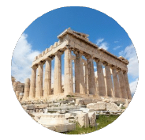
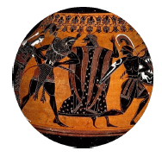
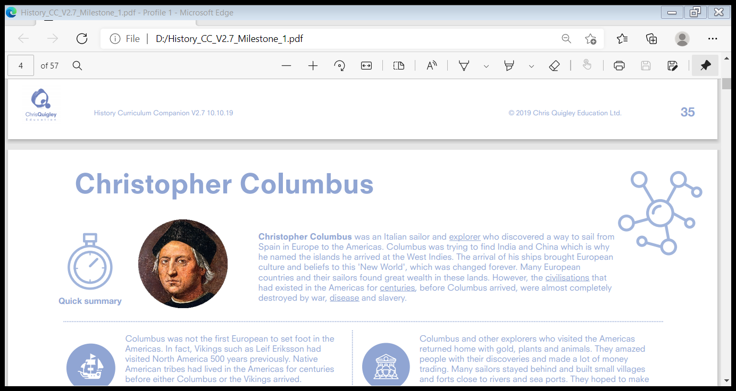
The Ancient Greeks: Myths & legends, beliefs and culture
- Ancient Greece was one of the earliest major civilisations of Europe, and its culture has had a significant impact on modern society. - The Greeks told some of the greatest, most influential and powerful stories, through their myths and legends. These famous texts, which are still read by thousands today, provided inspiration and guidance for the Ancient Greeks to explain their daily lives and understand the world around them.
- Athens was one of the first city-states to use a democratic system of government. Due to Ancient Greece’s Greek language, architecture, art and culture, it is possible to argue that Ancient Greece was the most influential ancient civilisation in history.


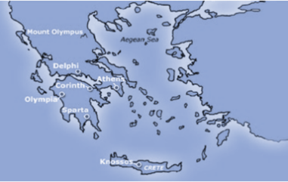










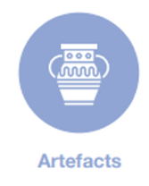


Acoustics: the features of a building that affect how sound is heard
Amphora: two-handled narrow necked jars for oil and wine
Architects: people who design buildings
Civilisations: organised groups of humans with their own culture
Democratic: based on the idea that everyone has equal rights and is involved in making decision
Engineering: using scientific knowledge to build
Generation: people in a group of similar age
Lekythos: flasks with a narrow neck
Literature: written work, especially with artistic value
Techniques: particularly skilful methods for doing something
- ‘The Iliad’ and ‘The Odyssey’, have influenced writing, storytelling and literature for almost three thousand years. These stories can be found painted on Greek pottery and are also a valuable source of evidence about Greek life, culture and religious beliefs.
- Some of the objects show the red- figure and black-figure pottery techniques. The red-figure technique shows red figures (usually Greek gods or heroes) against a black background.
- Black-figure pottery is the opposite. Amphoras were used to store wine and grain, while lekythos were used to store ointments and oils.

The Ancient Greeks believed in three generations of gods. The first generation – the sky, the earth, the heavens, mountains and other physical things – came into existence from nothing. The second generation were called the Titans (also known as the elder gods) and were the children of Uranus (heaven) and Gaia (earth). There were twelve Titans in total, six female and six male. From these gods came the third generation, the Olympians, who took on the appearance of men and women.
- For the Ancient Greeks, physical education and competitive sports were a significant part of their culture. They held athletic competitions near Mount Olympus which inspired the modern Olympic Games.
- The Greek city-states shared many traditions, stories and festivals. Famous myths and legends (like Theseus and the Minotaur) told stories about gods, heroes and how the universe was created as well as telling people how to behave in everyday life.
- The amphitheatre was a central part of their life and plays were a vital part of religious festivals. Almost every Greek city had a theatre. Built on hillsides, these semi-circular open-air theatres were designed to give everyone in the audience a good view. The acoustics were excellent and are evidence of the superb engineering and building skills developed by the Ancient Greeks. The theatre of Dionysus (the Greek god of wine, fertility and entertainment) on the slope of the Acropolis in Athens, is the oldest theatre in Greece. The Epidaurus amphitheatre is the largest and most well-preserved.

