
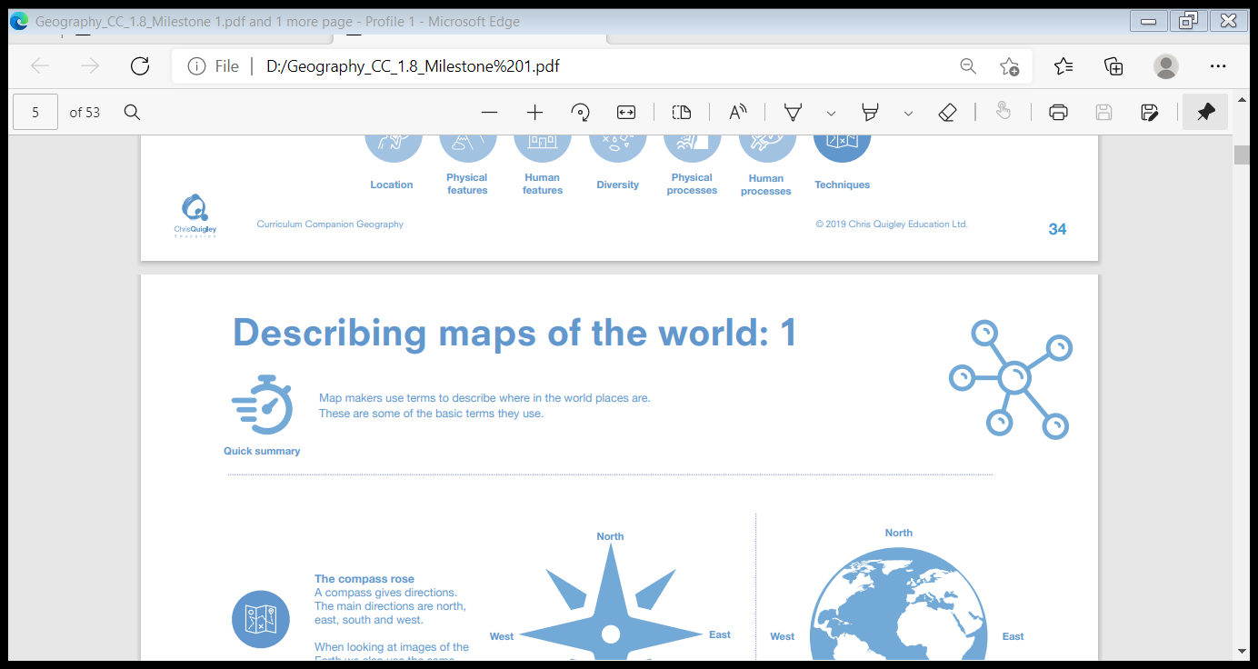
What matters most to Humanists and Christians?
Make sense of belief: Identify and explain beliefs about why people are good and bad (e.g. Christian and Humanist)
• Make links with sources of authority that tell people how to be good (e.g. Christian ideas of ‘being made in the image of God’ but ‘fallen’, and Humanists saying people can be ‘good without God’)
Understand the impact: Make clear connections between Christian and Humanist ideas about being good and how people live
• Suggest reasons why it might be helpful to follow a moral code and why it might be difficult, offering different points of view
Make connections: Raise important questions and suggest answers about how and why people should be good
• Make connections between the values studied and their own lives, and their importance in the world today, giving good reasons for their views.

Humanist: a person who seeks natural explanations to answer life’s big questions and for events in the world around them
Belief: trust or confidence in something
Moral: acting in the correct way
Golden Rule: to treat other people as you want to be treated
Humanism: a non-religious worldview of life and the world
Worldview: a person’s view of the world
Christian: a person who follows Christianity and believes Jesus is the Saviour who healed the rift between humanity and God.
Values: something that is important in terms of what you believe or how you act
Authority: having power over something or someone
Non-religious: not believing in a religion

PUPILS WILL KNOW THAT…
-Everybody in the world has their own personal worldview and this can be religious or non-religious. There are similarities and differences between these different worldviews.
-All worldviews have different moral ways of living and this affects how people treat other people and the world around them.
-A Christian will have values which are based on the life of Jesus and the teachings of the Christian Church. For many Christians the Bible has authority because for many it is the Word of God.
-People who hold Humanism as a world view will have the belief that they should be free to work out for themselves what makes us happy
and that we should be kind to the planet and animals. A person who holds this worldview is
known as a Humanist. Not all non-religious people are humanists.
-Treating others as we want to be treated can be found in many worldviews and is called The Golden Rule
Salvation Incarnation God Creation Gospel Fall

