
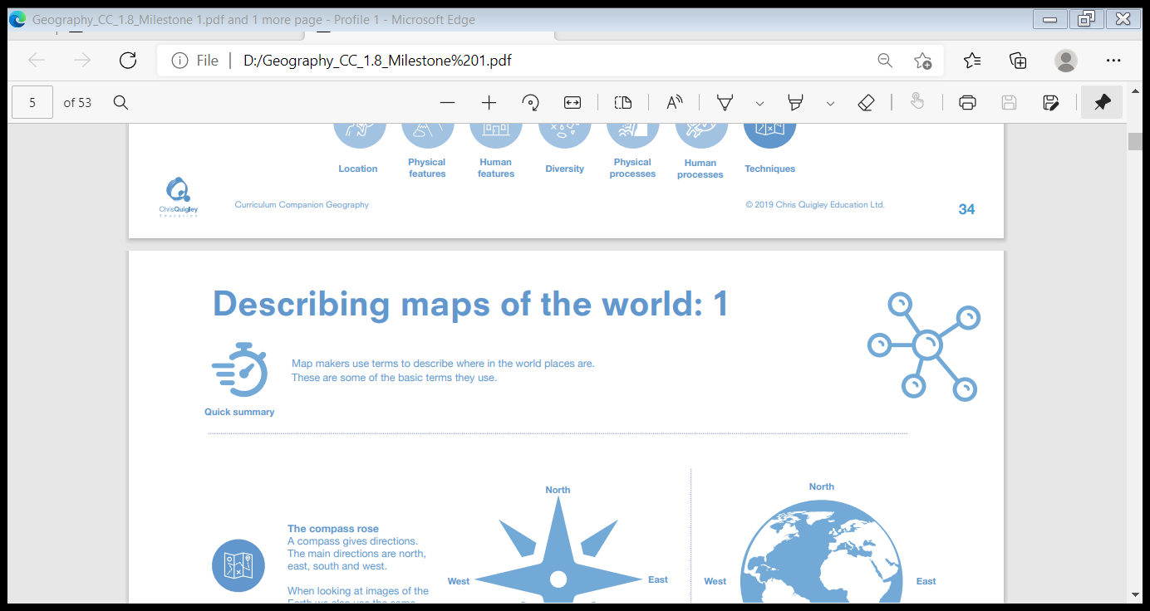
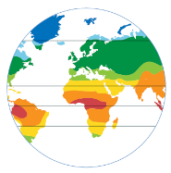
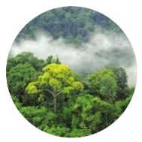
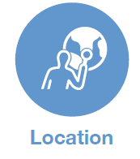
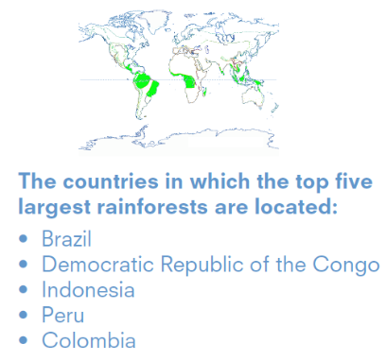
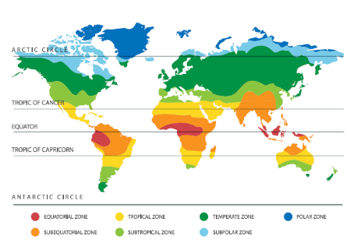
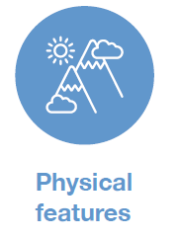










Biomes and climate zones
categorise: to put into groups (categories)
inhabit: to live in
terrestrial: on land
aquatic: in water
climate: the average expected weather in a place
equatorial: at the equator
precipitation: rain, snow, sleet or hail
Animals and reptiles that live in rainforest habitats include: boa constrictor, capybara, forest elephant, giant anteater, jaguar, macaw, marmoset, poison dart frog, sloth, spider monkey, tamarin, tapir, toucan and tree frog. Insects and bugs that live in rainforest habitats include: clear winged butterfly, dragonfly, goliath birdeater spider, leaf insect, leafcutter ant and long-horned beetle. Trees and plants that live in rainforests include: bromeliad, cacao tree, carnivorous plants, epiphytes, lianas (vines), orchid and rubber tree.
We get many items of food such as bananas, chocolate, coffee, nuts, coconut, cinnamon and rubber from the rainforests. About 25 per cent of the medicines we use come from plants in the rainforest. Deforestation is a major problem for the world’s climate.
Location of Earth’s climate zones
Location of Earth’s biomes
Biomes are a way to categorise the Earth's surface. These categories are based on climate patterns, soil types and the animals and plants that inhabit an area. There are terrestrial biomes and aquatic biomes. Every part of the Earth's surface is a part of one or more biomes. Biomes are directly linked to climate zones.

Tropical rainforests are rainforests that occur in the equatorial and sub-equatorial climate zones, which are in the tropics. They are hot, wet places with high levels of precipitation – sometimes up to 10 metres (33 ft) of rain can fall in a year.

