
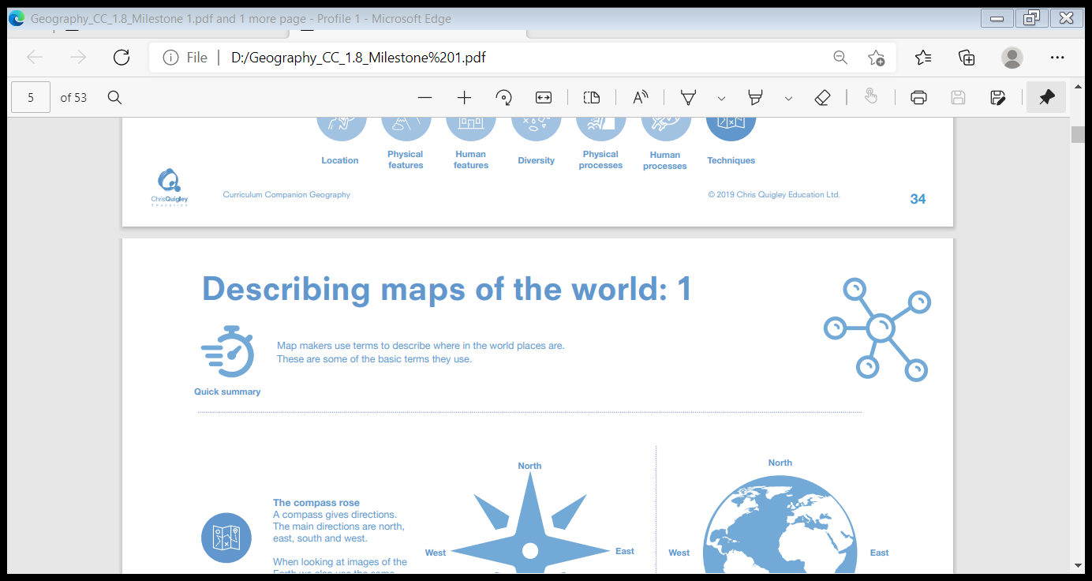
Judaism
Unit U2.9: Why is the Torah so important to Jewish people?
Torah: the Jewish Holy Book made of the five books of law
Sefer Torah: the scrolls containing the Torah which are kept in the ark in the synagogue
Orthodox: a worldview in Judaism following the traditional interpretation of Jewish law.
Pesach (Passover): the festival remembering the Israelites leaving slavery in Egypt
Synagogue: the Jewish place of worship sometimes called shul
Kosher: something which follows Jewish laws
Progressive: worldview in Judaism which says that the laws of the Torah should be interpreted for modern day life
Kashrut: Jewish laws about the suitability of food
Secular: not connected with religious or spiritual matters
- The Jewish people are a diverse group with different views about how the laws in the Torah are applied in everyday life. The Torah is important to all Jewish people and every synagogue will have a Sefer Torah contained in an ark to show how important and special it is. The Torah will tell Jewish people what God allows them to do and what God wants them to do.
- Anything that God allows Jewish people to do is known as kosher. When this is applied to what Jews can and cannot eat this is known as kashrut, for example a Jewish person cannot eat pork as God forbids it.
- Orthodox Jewish people will follow what God has told them exactly in the Torah as it is the word of God. Progressive Jewish people believe that the Torah was written by humans and reflects the place of God in the life of the author. They will interpret the Torah for modern day life as some of the laws cannot be followed today. Secular Jewish people identify as being Jewish but do not tend to identify with Jewish beliefs.
- Pesach is a very important Jewish festival which can be celebrated differently by the different Jewish groups. Some Jewish people may choose to remember Miriam at Pesach whilst other Jewish people may have a vegan meal to reflect what they believe.
Make sense of belief:
• Identify and explain Jewish beliefs about God
• Give examples of some texts that say what God is like and explain how Jewish people interpret them
Understand the impact:
• Make clear connections between Jewish beliefs about the Torah and how they use and treat it
• Make clear connections between Jewish commandments and how Jews live (e.g. in relation to kosher laws)
Make connections:
• Make connections between Jewish beliefs studied and explain how and why they are important to Jewish people today
• Consider and weigh up the value of e.g. tradition, ritual, community, study and worship in the lives of Jews today, and articulate responses on how far they are valuable to people who are not Jewish.

Salvation Incarnation God Creation Gospel Fall

