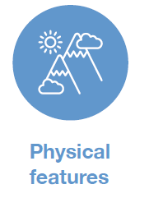
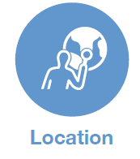

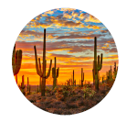
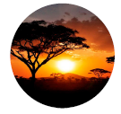

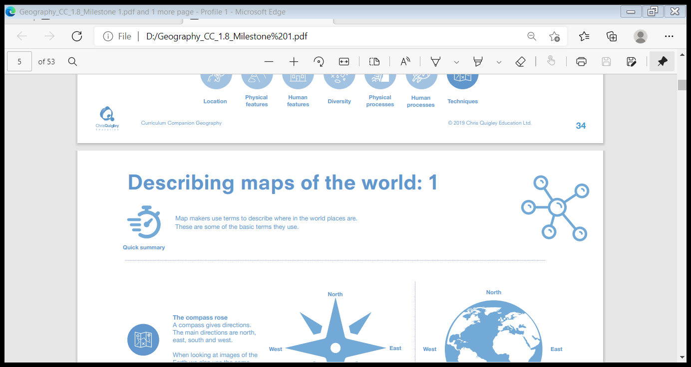







Desert and Savannah Biome
Daytime temperatures in the desert biome are very high, but can be very low at night. Some deserts are so hot that when it rains, the water evaporates in the air before hitting the ground. The driest desert on Earth gets on average 1 cm of rainfall every 5 to 20 years.

The savannah is warm all year long. It is mostly made up of grass but there are sporadic trees. The savannah biome, is not suitable for farming. Water holes provide drinking water for roaming animals.
. Desert animals tend to be nocturnal, sleeping during the day and coming out at night when the temperatures are more tolerable.
.There is hardly any standing water in the desert biome, so animals either store water in their bodies or get their water needs met by the foods they eat.
. The plants that are able to grow in the desert biome store water in their stem. The camel stores all its body fat in its hump. Cacti’s spines protect them from being eaten by animals and their waxy outer covering prevents moisture from escaping.
. In the savannah, there are many herbivores, such as elephants, zebras, gazelles and buffalo, who take advantage of the abundant food supply. Herbivores have developed traits, such as being fast, large or tall, which help them escape carnivorous predators, e.g. lions.
. The savannah biome has a long dry season so plants there have adapted to this climate.
Ecosystem: all the conditions, plants and animals that exist in a particular area
Arid: dry
Evaporates: turns from a liquid into a gas
Vegetation: plants and trees
Nocturnal: being active at night
Sporadic: only in a few places
Roaming: wandering around
Grazing: grass-eating
Desertification: becoming like a desert
Abundant: more than enough
Carnivorous: meat-eating
Predators: animals that hunt other animals
The desert biome is an ecosystem that forms due to the low level of rainfall it receives each year. Deserts cover about 20 per cent of the Earth. There are four major types of desert in this biome: hot and dry, semi-arid, coastal, and cold. They all have plant and animal life that have adapted to survive there. The desert biome is a big tourist attraction. People enjoy rock climbing, cycling and hiking in the desert.

A savannah is a rolling grassland scattered with shrubs and isolated trees. The savannah biome is an area that has a very dry season and then a very wet season. Tourism is popular, especially in areas such as the Serengeti National Park in Tanzania
The Sahara Desert is the largest desert in the desert biome. It covers over 300 million square miles (776 square km). The desert biome can be found on every continent except Europe.
The largest part of the savannah biome is located in Africa. The Serengeti plains of Tanzania in Africa are probably the best known African savannah. Other areas are found in North America and the North and East of South America (Brazil).
Location of the desert biome
Location of the savannah biome

