Appendix B: PSHE Association Medium Term Planning
This sets out in more detail the learning that will take place in each year group.

Year 1


Year 2
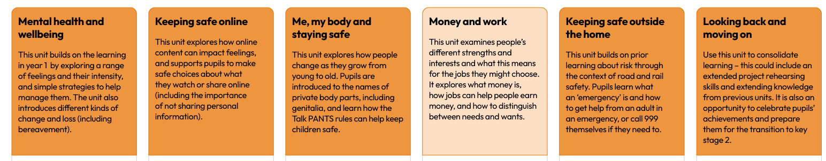

Year 3
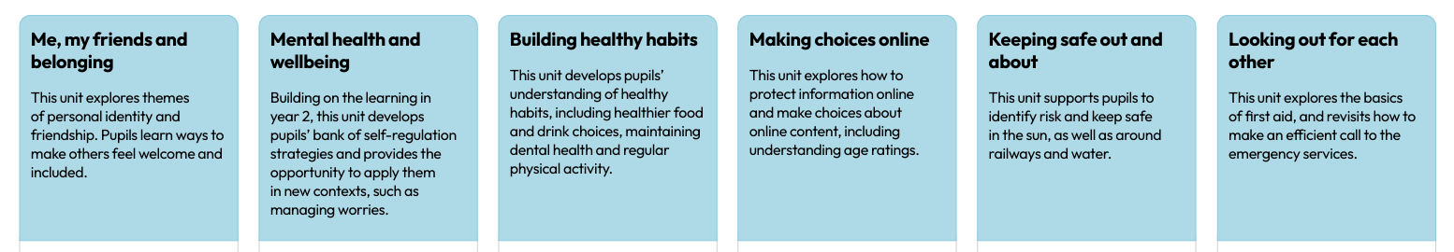

Year 4

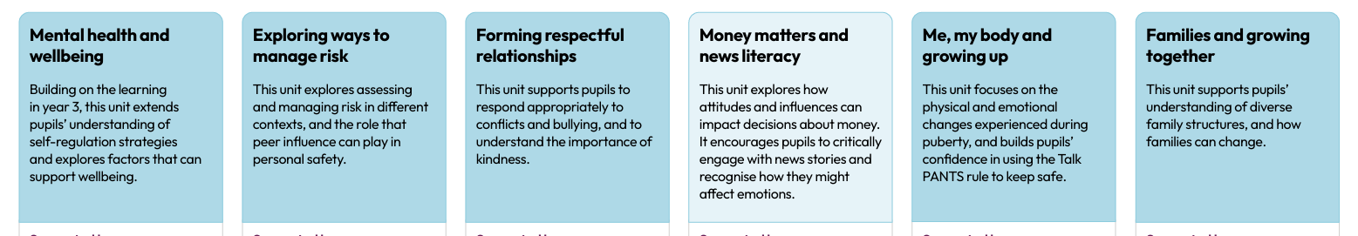

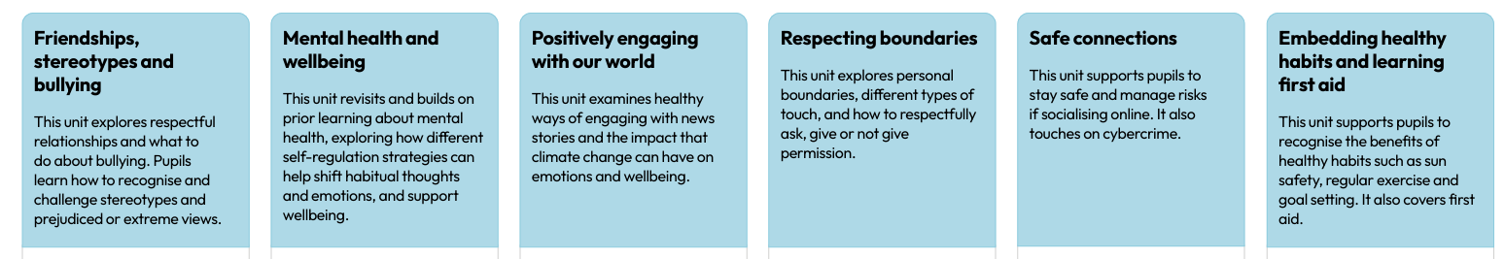
Year 5
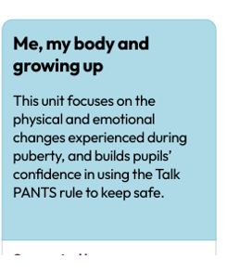

Year 6



