St Oswald’s CE Primary School and Nursery

Personal, Social, Health and Economic Education (PSHE) Policy



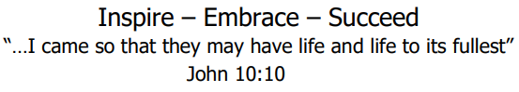

Policy review date: June 2026
Next review date: June 2028
Policy Statement
This policy outlines the Intent, Implementation and Impact of how PSHE is taught using a spiral curriculum in our school. The PSHE Policy should be read in conjunction with the following policies: RSHE, SEND, and Safeguarding.
The Implementation of this policy is the responsibility of all teaching staff.
The school policy for PSHE reflects the consensus of opinion of the whole teaching staff and has the full agreement of the Governing Body.
At St Oswald’s our PSHE curriculum is planned using the PSHE Association curriculum model, which supports the children’s personal development, physical and mental health and well-being, economic awareness, understanding of relationships and how to keep safe both in the real world and online.

Our school vision
At the heart of our vision is John 10:10 “…I came so that they may have life and life to its fullest.” Our PSHE education programme is underpinned by our whole school vision: Inspire, Embrace, Succeed
We want our school to inspire those in it and around it; to be a place where dreams are dreamt, goals are met and where confidences are grown. We aim to inspire children in their learning to explore the world around them and to seek out new experiences. We hope that our children will aspire to be kind (forming positive relationships) and grow to become adults who can help themselves to be independent. We want those in our school to embrace life! To take every opportunity given, respect who and what is around them and to uphold the Christian values of our school. We want those in our school to reach their fullest potential; to try their hardest, to give of their best and not give in – to succeed!

Statutory Requirements
Under the Education Act 2002 and the Academies Act 2010 all schools must provide a curriculum that:
- Promotes the spiritual, moral, cultural, mental and physical development of pupils
- Prepares pupils for the opportunities, responsibilities and experiences of later life

We are required by law to teach Relationships Education and Health Education and we deliver these statutory subjects within our PSHE programme. This is fully in line with the 2025 Relationships, Sex and Health Education (RSHE) statutory guidance.

Intent:
Through our curriculum, our school environment, our school vision and values as well as the strength of our relationships, we strive to promote pupils’ self-esteem and emotional and physical well-being. We want to help them to form and maintain worthwhile and satisfying relationships, based on RESPECT for themselves and for others, at home, at school and in the wider community. Our PSHE curriculum intends to prepare the children for further education and life beyond the classroom, developing their resilience, confidence, and independence.
At St Oswald’s, we create a safe and supportive learning environment by ensuring that staff are equipped to answer questions from the children. Children are always encouraged to ask questions in a safe and secure environment. We will ensure that where pupils indicate that they may be vulnerable and at risk, they will get appropriate support by making sure there is an opportunity for them to speak to someone about any issues and the correct support or referrals made if needed. This policy is informed by the school’s safeguarding policy and staff are aware of and have regular training of child protection and how to support our vulnerable children.
At St Oswald’ we promote the needs and interests of all pupils, irrespective of gender, culture, ability, or personal circumstance by ensuring that our curriculum is inclusive. Teaching will consider the age, ability, readiness, and cultural backgrounds of children and those with English as a second language to ensure that all can fully access PSHE education provision. We recognise the right for all children to access PSHE education learning which meets their needs. We will ensure that pupils with SEND receive access to PSHE through universal and targeted adaptations, where appropriate, and extra support where necessary.
We always expect our pupils to consider others’ needs by showing respect towards the others in their class.
Implementation:
Teaching and learning
PSHE will be taught by the children’s class teacher as well as PPA cover teachers. Where the lesson content is more sensitive, it is our policy for those lessons to be taught by the children’s class teacher, who will be better placed to manage difficult questions or disclosures in line with our safeguarding policy.
We will determine pupils’ prior knowledge/starting points by using baseline assessment activities using key questions around a topic or theme to see what they already know about it. This could take the form of a spider diagram, sorting activity, quiz or hot seating. The programme will be taught through a range of teaching methods, including written work, drama, the use of video clips and visitors.
Teaching in PSHE must always reflect the diversity that is present in modern society. For example, descriptions of families must be inclusive of the children’s own experiences.
We will help pupils make connections between their learning and ‘real life’ behaviours by ensuring that they have time to critically reflect on the learning that have had. They need to be able to see how this relates to them and others like them. The use of children voice is very important.
Children’s learning in PSHE is documented in each year group’s class book which contains the objectives being covered, evidence of discussions, reflections from the pupils and examples of work. Work completed by the children in PSHE lessons is also kept in a file for each class.
Planning:
At St Oswald’s we follow the PSHE Association model. This has been adapted to best fit our school context and fulfils all statutory guidance.

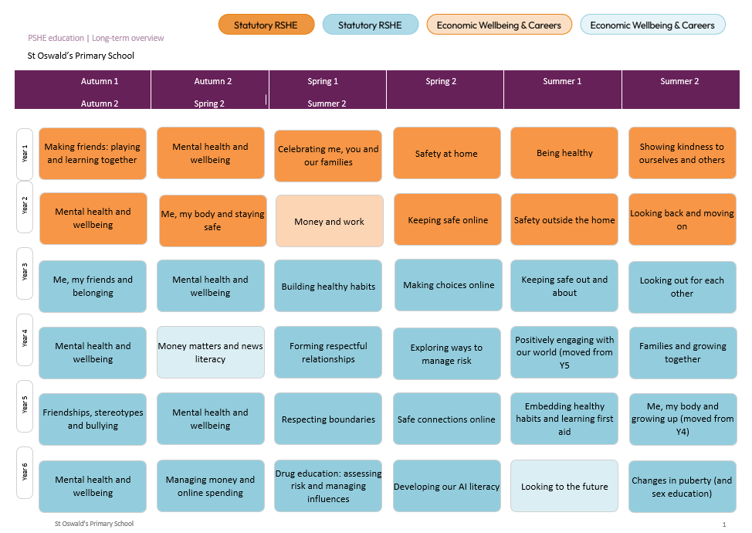
Our PSHE education addresses both pupil’s current experiences and preparation for their future. The structure provides a spiral curriculum to develop knowledge, skills and attributes, where prior learning is revisited, reinforced and extended. This is grounded in the established evidence base for effective practice in PSHE education.
The Programme of Study covers a wide range of important issues. At St Oswald’s, we want our PSHE lessons to be responsive to the needs of the children and the wider community. Therefore, we will plan and resource lessons to address any issues that arise, such as the rising popularity of vaping among young people. We will ensure that all information used to develop pupil’s knowledge is up to date and accurate.
In addition, we will use external contributors such as, community police, Purple Leaf, NSCPCC, Google legends, first aid training and have access to a school nurse and The Money Charity money programmes. When using external speakers to deliver aspects of our PSHE programme we will ensure that they are DBS checked where needed and that school are aware of what learning outcome and information they will be delivering to the children. We will consider if any views or activities of the organisation or speaker could conflict with school values, safeguarding duties, British Values or Prevent. Many of our external speakers will come recommended through the PSHE association where possible.
As part of our planning and teaching, we will refer to and make links with our whole school Christian values.
Timetabling
We allocate a minimum of 45 minutes a week of curriculum time to PSHE education. Our PSHE education provision is mapped and planned effectively through the guidance from the PSHE association. Online safety is taught in computing lessons (using materials from Evolve) as well as PSHE lessons. Our online safety planning for each year group includes key learning objectives from both curriculums. Other cross curricular links are made with science (our bodies) and with design technology (food).
Our provision is further enriched by weekly assemblies focussing on our school values. We also have community events to help promote good relationships and community links; external visitors and assemblies to complement the themes in school and special events to help support cementing children’s learning into semantic memory. Our TIS lead, SENCO and DSL are available to support the class teacher when appropriate.
Assessment and Monitoring
Assessment in PSHE takes a formative approach, with the children’s discussions and reflections being used to identify misconceptions and plan next steps for learning. Each year group has a summary of key knowledge and skills that the children are expected to attain, and teachers record pupil’s achievements against these criteria. Opportunities for assessment include:
- Observations of discussions, role play and collaborative activities
- The use of oral ‘Smart Starts’ and or flashcards to check understanding of previous knowledge taught
- Reviews of children’s written work and their reflections in class PSHE books.
The programme will be led by our PSHE Lead who will monitor the delivery through learning walks, lesson observations, book looks, pupil conversations and staff and parent feedback. Teachers responsible for teaching PSHE will receive training through the PSHE co-ordinator and have access to all PSHE resources in school and on the school system. Extra support will be given if identified or requested.
Involving Parents and Carers
We are committed to working with parents and carers. We recognise that parents are children’s first and most important educators. PSHE education is most effective when parents and carers carry on the conversations started at school. We will offer support by ensuring that parents are aware of the themes that we are teaching their child each year. This information is available on the school website, on learning reviews and on our newsletters.
We engage parents when updating our policies by making these available on our website and making teaching materials available for parents to view. The materials used in sex education lessons are made available for parents to view beforehand and we communicate to parents about their right to withdraw their children from the Sex Education part of PSHE curriculum. If a parent wishes to withdraw their child, we will ensure that they are removed for the class only when PSHE is concentrating on Sex Education. Any questions or concerns are welcomed and should be raised with the class teacher in the first instance and then with senior leaders where needed.

Impact
A growing body of research shows that pupils who are emotionally healthy do better at school. PSHE education helps children and young people to achieve their potential by supporting their wellbeing and tackling issues that can affect their ability to learn, such as anxiety and unhealthy relationships. The skills and attributes developed through PSHE and RSHE are also shown to increase academic attainment and attendance rates, particularly among pupils eligible for free school meals, as well as improve employability and boost social mobility. By the time they leave our school, PSHE and enables our learners to become healthy, independent, and responsible members of a society. It helps them understand how they are developing personally and socially, and tackles many of the moral, social and cultural issues that are part of growing up. Our curriculum allows pupils to learn about rights and responsibilities and appreciate what it means to be a member of a diverse society. Our children are encouraged to develop their sense of self-worth by playing a positive role in contributing to school life and the wider community.
Policy Availability
The policy is available [to parents and carers] through the school website on the PSHE page. If you require this policy or any of the documents in printed form please contact the school office.
Review date: June 2028
This policy will be reviewed by the PSHE lead and SLT to ensure that it follows any current guidance from the DfE and the PSHE association.

