Relationship and Sex Education (RSE) and Health Policy



Recommended by | Mrs C Reece. Headteacher  Miss S Collins. PSHE Lead
Recommendation date: | 30.09.2021
Signed | 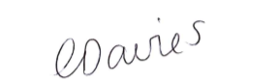
Position | CEO
Approval date | 04.10.2021
Review date | September 2023
Approval level: | School
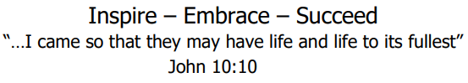

Relationship and Sex Education (RSE) and Health Policy.
St Oswald’s is a Church of England Primary school. At the heart of our vision is John 10:10: “…I came so that they may have life and life to its fullest.” In order for all to achieve their potential we are committed to creating an environment where positive relationships are at the heart of productive learning.
This Policy was written & reviewed by:
Mrs Carol Reece: Headteacher
Mrs Hannah Ashton: PSHE Lead
Miss Sarah Collins: PSHE Lead

Statement of Intent
At St Oswald’s CE Primary School, we understand that pupils must be provided with an education that prepares them for the opportunities, responsibilities and experiences of adult life. A key part of this relates to relationships education, which must be delivered to every primary-aged pupil. Primary schools also have the option to decide whether pupils are taught sex education. State-funded primary schools are also required to teach health education.
Relationships education focuses on giving pupils the knowledge they need to make informed decisions about their wellbeing, health and relationships, and to build their self-efficacy. Health education focuses on equipping pupils with the knowledge they need to make good decisions about their own health and wellbeing.
We understand our responsibility to deliver a high-quality, age-appropriate and evidence-based relationships, sex and health curriculum for all our pupils. This policy sets out the framework for our relationships, sex and health curriculum, providing clarity on how it is informed, organised and delivered.
In addition, our policy is shaped around the inclusive values detailed in The Church of England Education Office document; ‘Valuing all God’s children.’ (p18-25.)
‘Inclusivity and hospitality should be the hallmarks of Church of England schools: every child should be revered and respected as a member of a community where all are known and loved by God.’(p24)
Documents that inform the school’s RSE policy include:
- Education Act (1996)
- Learning and Skills Act (2000)
- DfE 2000 Sex and Relationships Education guidance.
- Education and Inspections Act (2006)
- Equality Act (2010)
- Supplementary Guidance SRE for the 21st century (2014)
- Children and Social Work Act (2017)
- Keeping children safe in education – Statutory safeguarding guidance (2020)
- Sex and Relationship Education (SRE) for the 21st century' (2019)
- Valuing All God’s Children (2019)
- Relationship and Sex Education (RSE) and Health Education (2020)
- Development Matters - non-statutory curriculum guidance for EYFS (2020)
- DfE (2013) ‘Science programmes of study: key stages 1 and 2’
Links with other school policies
- Child Protection and Safeguarding Policy
- Behaviour Policy
- SEND Policy
- Equality Policy
- Anti-Bullying Policy
- eSafety Policy

Roles and responsibilities
The local academy board is responsible for:
- Ensuring all pupils make progress in achieving the expected educational outcomes.
- Ensuring the curriculum is well led, effectively managed and well planned.
- Evaluating the quality of provision through regular and effective self-evaluation.
- Ensuring teaching is delivered in ways that are accessible to all pupils with SEND.
- Providing clear information for parents on subject content and their rights to request that their children are withdrawn.
- Making sure the subjects are resourced, staffed and timetabled in a way that ensures the school can fulfil its legal obligations.
- Ensuring the religious ethos of the school is maintained and developed through the subjects.
- Creating and keeping up-to-date a separate written statement of this policy and ensuring the statement is published on the school’s website and provided free of charge to anyone who requests it.
The headteacher is responsible for:
- The overall implementation of this policy.
- Ensuring staff are suitably trained to deliver the subjects.
- Ensuring that parents are fully informed of this policy.
- Reviewing requests from parents to withdraw their children from the subjects.
- Discussing requests for withdrawal with parents.
- Organising alternative education for pupils, where necessary, that is appropriate and purposeful.
- Reporting to the local advisory board on the effectiveness of this policy.
- Reviewing this policy on an annual basis.
The relationships, sex and health education subject leader is responsible for:
- Overseeing the delivery of the subjects.
- Ensuring the subjects are age-appropriate and high-quality.
- Ensuring teachers are provided with adequate resources to support teaching of the subjects.
- Ensuring the school meets its statutory requirements in relation to the relationships, sex and health curriculum.
- Ensuring the relationships, sex and health curriculum is inclusive and accessible for all pupils.
- Working with other subject leaders to ensure the relationships, sex and health curriculum complements, but does not duplicate, the content covered in the national curriculum.
- Monitoring and evaluating the effectiveness of the subjects and providing reports to the headteacher.
Teachers are responsible for:
- Delivering a high-quality and age-appropriate relationships, sex and health curriculum in line with statutory requirements.
- Using a variety of teaching methods and resources to provide an engaging curriculum that meets the needs of all pupils.
- Ensuring they do not express personal views or beliefs when delivering the programme.
- Modelling positive attitudes to relationships, sex and health education.
- Responding to any safeguarding concerns in line with the Child Protection and Safeguarding Policy.
- Acting in accordance with planning, monitoring and assessment requirements for the subjects.
- Liaising with the SENCO to identify and respond to individual needs of pupils with SEND.
- Working with the relationships, sex and health education subject leader to evaluate the quality of provision.
The SENCO is responsible for:
- Advising teaching staff how best to identify and support pupils’ individual needs.
- Advising staff on the use of Teaching Assistants in order to meet pupils’ individual needs.
Policy Aims
The aim of our SRE is to provide opportunities for our children to experience a programme of relationships and sex education that is at a level which is appropriate for their age and physical development. The programme will aim to build knowledge and life skills over time in a way that prepares pupils for the future regardless of sexual orientation or gender identity.
Sex and relationships education is learning about the emotional, social and physical aspects of growing up, relationships, sex, human sexuality and sexual health. Some aspects are taught in science, and others are taught as part of timetabled Personal, Social, Health and Economic education (PSHE) sessions. The programme gives children and young people essential skills for building positive, enjoyable, respectful and non-exploitative relationships and the tools to enable them to stay safe both on and offline.

Definitions for the purpose of this policy:
- “Relationships and sex education” is defined as teaching pupils about healthy, respectful relationships, focussing on family and friendships, in all contexts, including online, as well as developing an understanding of human sexuality.
- “Health education” is defined as teaching pupils about physical health and mental wellbeing, focussing on recognising the link between the two and being able to make healthy lifestyle choices. These include fitness, healthy eating, drugs, alcohol and tobacco, health and prevention, basic first aid and an introduction to the key changes to the body, during puberty.
How does RSE fit in with the PSHE Curriculum?
Every primary school is required to deliver statutory relationships education and health education.RSE is taught in conjunction with, Personal, Social and Health Education (PSHE); as well as the National Curriculum for Science. The RSE curriculum reflects the values of the PSHE programme (see appendix 3) and is taught in the context of healthy relationships as well as developing self-esteem, emotional health and wellbeing and promoting a healthy and safe lifestyle. It aims to help children develop confidence in talking, listening and thinking about feelings and relationships; to form and maintain worthwhile relationships that are based on respect for themselves and others and to understand ways that they can protect themselves and others and ask for support. The children are able to take care of their own body, name parts of the body, describe how bodies work and are prepared for puberty.
We adhere to the advice detailed in the supplementary guidance; ‘Sex and Relationships Education SRE for the 21st Century’ published by the PSHE Association and the statutory guidance; Relationships Education, Relationships and Sex Education (RSE) and Health Education (DFE/2019). These documents reflect updated legislation, in particular the Equality Act (2010).

Policy development, consultation and review
The relationships and health curriculum takes into account the views of teachers, pupils, parents and carers. The school has organised a curriculum that is appropriate for the age and developmental stages of pupils within each year group. When organising the curriculum, the religious backgrounds of all pupils will be considered, so that the topics that are covered are taught appropriately.
We are dedicated to ensuring our curriculum meets the needs of the whole-school community; therefore, the curriculum is informed by issues in the school and wider community to ensure it is tailored to pupils’ needs. For example, if there were to be a local prevalence of drug misuse, our curriculum would be tailored to address this issue.
We consult with parents, pupils and staff in the following ways:
- Questionnaires and surveys
- Meetings
- Training sessions
- Newsletters and letters
Consultation with pupils

St Oswald’s will involve its students from Years 1 to Year 6 in having a say in developing RSE practice. RSE will be audited and reviewed regularly to ensure that it meets the needs of our pupils.
Pupils in the Early Years Foundation Stage, will be entitled to good quality PSED (Personal, Social and Emotional Development) which meet their needs. St Oswald’s will involve its pupils in Nursery and Reception classes in developing PSED practice, as documented in Development Matters (2020).

Consultation with parents

The school understands the important role parents play in enhancing their children’s understanding of relationships, sex and health. Similarly, we also understand how important parents’ views are in shaping the curriculum. The school works closely with parents by establishing open communication – all parents are consulted in the development and delivery of the curriculum.
Any parent, teacher or pupil wishing to provide feedback about the curriculum can do so at any time during the academic year by:

- Organising a meeting with the headteacher or SRE Lead
- Emailing office@stoswalds.worcs.sch.uk.
- Submitting written feedback into the suggestions box in the school office
Parents are provided with the following information:

- The content of the relationships, sex and health curriculum
- The delivery of the relationships, sex and health curriculum, including what is taught in each year group
- The legalities surrounding withdrawing their child from the subjects
- The resources that will be used to support the curriculum
St Oswald’s aims to build positive relationships with parents by inviting them into school to discuss what will be taught, address any concerns and help parents in managing conversations with their children on the issues covered by the curriculum. Parents are consulted in the review of the curriculum and this policy, and are encouraged to provide their views at any time. This policy is approved by the school local Academy Board and is shared with the Senior Leadership Team to ensure that it is implemented in practice. The policy is available to view on the school’s website.

Relationships education overview
Families and people who care for me
By the end of primary school, pupils will know:
- That families are important for them growing up because they can give love, security and stability.
- The characteristics of healthy family life, commitment to each other, including in times of difficulty, protection and care for children and other family members, the importance of spending time together and sharing each other’s lives.
- That others’ families, either in school or in the wider world, sometimes look different from their family, but that they should respect those differences and know that other children’s families are also characterised by love and care.
- That stable, caring relationships, which may be of different types, are at the heart of happy families, and are important for children’s security as they grow up.
- That marriage represents a formal and legally recognised commitment of two people to each other which is intended to be lifelong.
- How to recognise if family relationships are making them feel unhappy or unsafe, and how to seek help or advice from others if needed.
Caring friendships
By the end of primary school, pupils will know:
- How important friendships are in making us feel happy and secure, and how people choose and make friends.
- The characteristics of friendships, including mutual respect, truthfulness, trustworthiness, loyalty, kindness, generosity, trust, sharing interests and experiences, and support with problems and difficulties.
- That healthy friendships are positive and welcoming towards others, and do not make others feel lonely or excluded.
- That most friendships have ups and downs, but that these can often be worked through so that the friendship is repaired or even strengthened, and that resorting to violence is never right.
- How to recognise who to trust and who not to trust.
- How to judge when a friendship is making them feel unhappy or uncomfortable.
- How to manage conflict.
- How to manage different situations and how to seek help from others if needed.
Respectful relationships
By the end of primary school, pupils will know:
- The importance of respecting others, even when they are very different from them (for example, physically, in character, personality or backgrounds), make different choices, or have different preferences or beliefs.
- Which practical steps they can take in a range of different contexts to improve or support respectful relationships.
- The conventions of courtesy and manners.
- The importance of self-respect and how this links to their own happiness.
- That in school and wider society they can expect to be treated with respect by others, and that in turn they should show due respect to others, including those in positions of authority.
- About the different types of bullying (including cyberbullying), the impact of bullying, responsibilities of bystanders to report bullying to an adult, and how to seek help.
- What a stereotype is, and how they can be unfair, negative or destructive.
- The importance of permission-seeking and giving in relationships with friends, peers and adults.
Online relationships
By the end of primary school, pupils will know:
- That people sometimes behave differently online, including pretending to be someone they are not.
- That the same principles apply to online relationships as to face-to-face relationships, including the importance of respect for others online, even when we are anonymous.
- The rules and principles for keeping safe online.
- How to recognise harmful content and contact online, and how to report these.
- How to critically consider their online friendships and sources of information.
- The risks associated with people they have never met.
- How information and data is shared and used online.
Being safe
By the end of primary school, pupils will know:
- What sorts of boundaries are appropriate in friendships with peers and others – including in a digital context.
- About the concept of privacy and the implications of it for both children and adults.
- That it is not always right to keep secrets if they relate to being safe.
- That each person’s body belongs to them, and the differences between appropriate and inappropriate or unsafe physical, and other, contact.
- How to respond safely and appropriately to adults they may encounter, including online, who they do not know.
- How to recognise and report feelings of being unsafe or feeling bad about any adult.
- How to ask for advice or help for themselves and others, and to keep trying until they are heard.
- How to report concerns or abuse, and the vocabulary and confidence needed to do so.
- Where to seek advice, for example, from their family, their school and other sources.

Health education overview
Health education is compulsory for all state-funded primary schools.
The focus at primary level is teaching the characteristics of good physical health and mental wellbeing.
Mental wellbeing
By the end of primary school pupils will know:
- That mental wellbeing is a normal part of daily life, in the same way as physical health.
- That there is a normal range of emotions, e.g. happiness, sadness, anger, fear, surprise and nervousness.
- The scale of emotions that humans experience in response to different experiences and situations.
- How to recognise and talk about their emotions, including having a varied vocabulary of words to use when talking about their own and others’ feelings.
- How to judge whether what they are feeling and how they are behaving are appropriate and proportionate.
- The benefits of physical exercise, time outdoors, community participation, and voluntary and service-based activity on mental wellbeing and happiness.
- Simple self-care techniques, including the importance of rest, time spent with friends and family, and the benefits of hobbies and interests.
- How isolation and loneliness can affect children, and that it is very important they seek support and discuss their feelings with an adult.
- That bullying (including cyberbullying) has a negative and often lasting impact on mental wellbeing.
- Where and how to seek support (including recognising the triggers for seeking support), extending to who in school they should speak to if they are worried about themselves or others.
- That it is common to experience mental ill health and, for the many people who do, the problems can be resolved if the right support is made available, especially if accessed early enough.
Internet safety and harms
By the end of primary school, pupils will know:
- That for most people, the internet is an integral part of life and has many benefits.
- About the benefits of rationing time spent online.
- The risks of excessive time spent on electronic devices.
- The impact of positive and negative content online on their own and others’ mental and physical wellbeing.
- How to consider the effect of their online actions on others.
- How to recognise and display respectful behaviour online.
- The importance of keeping personal information private.
- Why some social media, some computer games and online gaming are age-restricted.
- That the internet can also be a negative place where online abuse, trolling, bullying and harassment can take place, which can have a negative impact on mental health.
- How to be a discerning consumer of information online, including understanding that information, inclusive of that from search engines, is ranked, selected and targeted.
- Where and how to report concerns and get support with issues online.
Physical health and fitness
By the end of primary school, pupils will know:
- The characteristics and mental and physical benefits of an active lifestyle.
- The importance of building regular exercise into daily and weekly routines and how to achieve this, for example by walking or cycling to school, a daily active mile, or other forms of regular, vigorous exercise.
- The risks associated with an inactive lifestyle, including obesity.
- How and when to seek support, including which adults to speak to in school, if they are worried about their health.
Healthy eating
By the end of primary school, pupils will know:
- What constitutes a healthy diet, including an understanding of calories and other nutritional content.
- The principles of planning and preparing a range of healthy meals.
- The characteristics of a poor diet and risks associated with unhealthy eating, including obesity, and other behaviours, e.g. the impact of alcohol on health.
Drugs, alcohol and tobacco
By the end of primary school, pupils will know the facts about legal and illegal harmful substances and associated risks, including smoking, alcohol use and drug-taking.
Health and prevention
By the end of primary school, pupils will know:
- How to recognise early signs of physical illness, such as weight loss or unexplained changes to the body.
- About safe and unsafe exposure to the sun, and how to reduce the risk of sun damage, including skin cancer.
- The importance of sufficient good-quality sleep for good health, and that a lack of sleep can affect weight, mood and ability to learn.
- About dental health and the benefits of good oral hygiene and dental flossing, including regular check-ups at the dentist.
- About personal hygiene and germs, including bacteria and viruses, how they are spread and treated, and the importance of hand washing.
- The facts and science relating to immunisation and vaccination.
Basic first aid
By the end of primary school, pupils will know:
- How to make a clear and efficient call to emergency services if necessary.
- Concepts of basic first-aid, for example dealing with common injuries, including head injuries.
Changing adolescent body
By the end of primary school, pupils will know:
- Key facts about puberty and the changing adolescent body, particularly from age 9 through to age 11, including physical and emotional changes.
- About menstrual wellbeing and key facts relating to the menstrual cycle.

Sex education

Although it is not statutory to deliver sex education outside of the science curriculum at primary level, the DfE recommends that all primary schools should have a sex education programme in place. This should be tailored to the age, and physical and emotional maturity of pupils, and should ensure that boys and girls are prepared for the changes that adolescence brings, drawing on knowledge of the human life cycle.

All pupils must be taught the aspects of sex education outlined in the primary science curriculum – this includes teaching about the main external parts of the human body, how it changes as it grows from birth to old age, including puberty, and the reproductive process in some plants and animals.
The school is free to determine whether pupils should be taught sex education beyond what is required of the national curriculum. At our school, we do teach pupils (specifically children in Year 6) some elements of sex education that is beyond what is required of the science curriculum. As part of sex education programme for year 6, we host an annual consultation meeting with parents/carers and staff to share the resources that will be used with the children.

Children will be encouraged to speak to their parents and carers about what they have learnt and to continue the learning at home. Parents/carers will be informed of this at the consultation session and be asked to speak to their children about their family values and beliefs.

PSHE Early Years Foundation stage
Children learn about the concept of male and female and about young animals. They develop skills to form friendships and think about relationships with others.
PSHE Key Stage 1
Children learn about growing and changing and some of the similarities and differences between boys and girls. This includes the importance of personal hygiene and health. They explore how there may be new opportunities and responsibilities that increasing independence brings.
They identify special people – family, friends and carers; what makes them special and how special people should care for one another. They learn to identify and respect differences and similarities between people and how their behaviour affects others. They begin to recognise what is fair and unfair, kind or unkind, right or wrong and use strategies to resolve simple arguments through negotiation. Children share their opinions on things that matter to them and share their views. They also learn to listen to other people and to play and learn cooperatively.
PSHE Key Stage 2
Children learn about the basic biology of human reproduction. They are taught about the physical, emotional and social changes at puberty including personal hygiene and how to take care of their body. They understand that they have the right to protect their body from unwanted contact and discuss how to get support if they have fears for themselves or their peers.
They continue to develop an understanding of relationships within a family, between friends and the community and that there are different patterns of friendship. They develop skills needed to recognise, form and build healthy relationships that respect other people’s emotions and feelings; similarities and differences. They learn how relationships may affect health and wellbeing; including mental health and consider healthy and safe online relationships. They think about how their increasing independence brings increased responsibility to keep themselves and others safe. and that their actions affect themselves and others. They learn ways to exercise some basic techniques for resisting pressures.
In addition, through the Science National Curriculum we teach children:
Key Stage 1
- That animals, including humans, move, feed, grow, use their senses and reproduce.
- To recognise and compare the main outer body parts of animals, including humans.
- That humans and animals reproduce offspring that grow into adults.
- To recognise similarities between themselves and other people and to treat other people sensitively.

Key Stage 2
- That the life processes common to humans and other animals include nutrition,
growth and reproduction.
- About the main stages of the human life cycle.

Organisation
Relationships and sex education is delivered through science, PSHE and values education. It is taught by class teachers and supported by teaching assistants. If appropriate, outside visitors, such as the school nurse, may take part.
A range of teaching methods are used including; DVD clips, group discussions and circle times. It is taught both with girls and boys together but where appropriate they are taught separately. When organising the curriculum, the religious backgrounds of all pupils will be considered, so that the topics that are covered are taught appropriately.
The resources used to teach aspects of Sex, sexuality and sexual health in year 5 and 6 specifically are:
All about us:
Living and Growing – Alternative; developed by Channel 4 Learning
It covers the following aims and topics:
Unit 1 Unit 2
Programme 1 Differences Programme 4 Changes
Programme 2 How did I get here? Programme 5 Girl Talk
Programme 3 Growing up Programme 6 Boy Talk

All topics will be dealt with sensitively, taking into account the needs of the cohort including those with special educational needs. Should any child become distressed by anything discussed and wish to leave the session, they will be able to do so and will be supported accordingly.
Parents’ right to withdraw
As school is legally obligated to provide pupils with Relationship Education (RE), parents do not have the right to withdraw their children from RE lessons.
It is important to note that parents do have the right to withdraw their child from the Sex Education elements of RSE only, but not the reproduction elements of the national curriculum for Science. To do this, parents should attend the annual Year 6 RSE parent session where they will have an opportunity to review resources used to teach children about reproduction (in year 6). If parents still wish to withdraw their child they must notify Mrs Carol Reece in writing prior to the day of delivery.
Safeguarding/Confidentiality/Reporting
Teachers need to be aware that effective relationship and sex education, which brings an understanding of what is and is not acceptable in a relationship, may lead to a disclosure of a child protection issue. If this happens staff should follow the guidance outlined in the schools Safeguarding and Child Protection policy. Under the common law young people are entitled to the same duty of confidence as adults. Personal information about them should not be shared without their permission except for the purposes of child protection.
We will ensure that every young person is clear who they can raise concerns with in school if they have witnessed or been the subject to sexual harassment or violence of any kind is not acceptable and will not be tolerated. Any students found to be behaving inappropriately will be sanctioned in accordance with our behaviour policy.
Should any parents be concerned about their child having witnessed or been the subject of inappropriate sexualised behaviour (including peer on peer abuse or online abuse), then they should report it immediately to a senior leader in school.
This policy must be read in conjunction with the academy’s Safeguarding and Child Protection policy and E-safety policy where there is wide-ranging guidance on specific safeguarding issues.
Monitoring and evaluation
The delivery of RSE is monitored by the designated RSE/PSHE curriculum leader and members of the senior leadership team.
Pupils’ development in RSE is monitored by class teachers as part of internal assessment systems.
This policy will be reviewed by key senior staff and primary RSE/PSHE subject leaders and in consultations with parents, staff and the school governing body annually.

Appendix 1 - PSHE Core Themes.
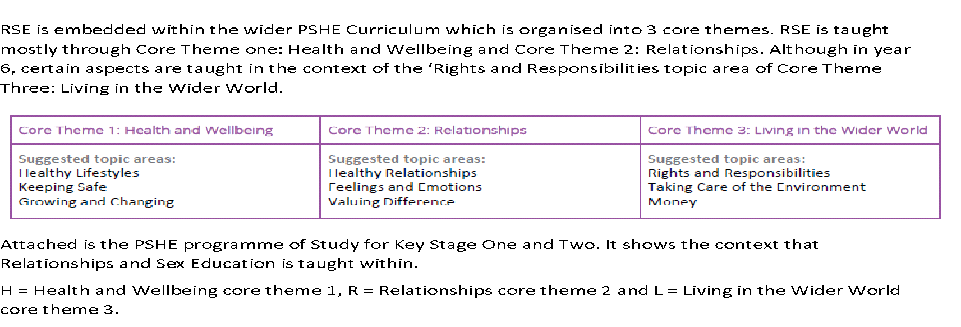
The learning opportunities in the Programme of Study (See Appendix 3) cover all of the content outlined in the Department for Education’s statutory Relationships, Sex and Health Education guidance, and go beyond this to integrate the statutory content within a complete and comprehensive PSHE education programme. The grids below set out where each aspect of the statutory guidance is covered by Programme of Study learning opportunities in key stages 1-4.

Appendix 2 - HOW DO THE PROGRAMME OF STUDY LEARNING OPPORTUNITIES RELATE TO THE STATUTORY GUIDANCE?
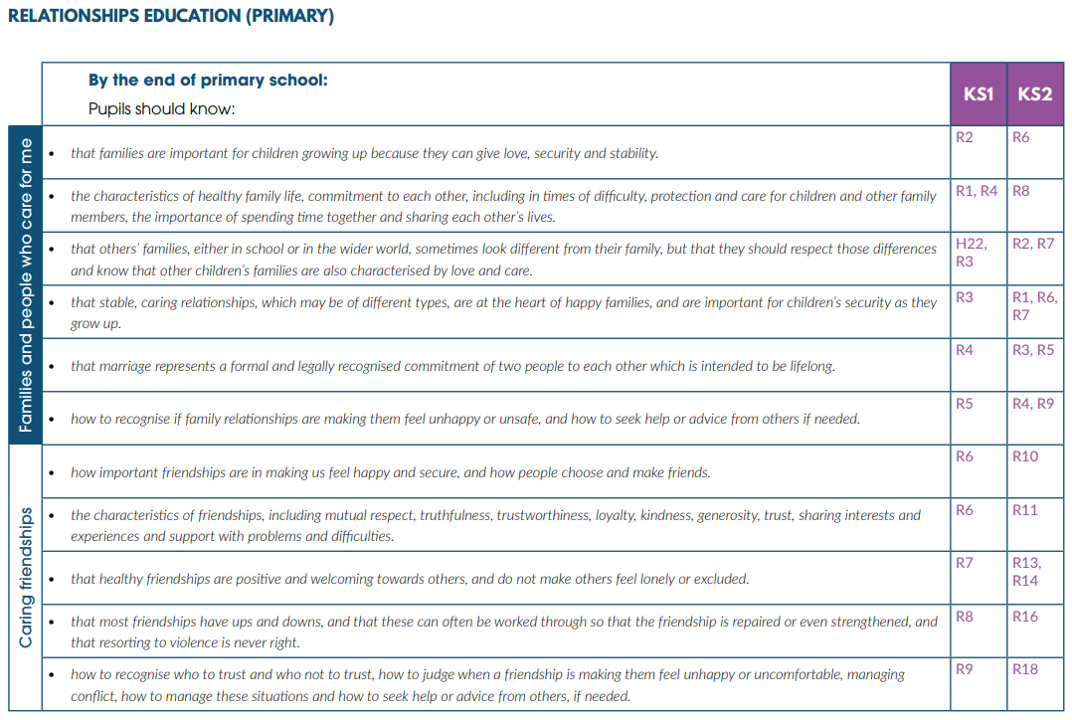

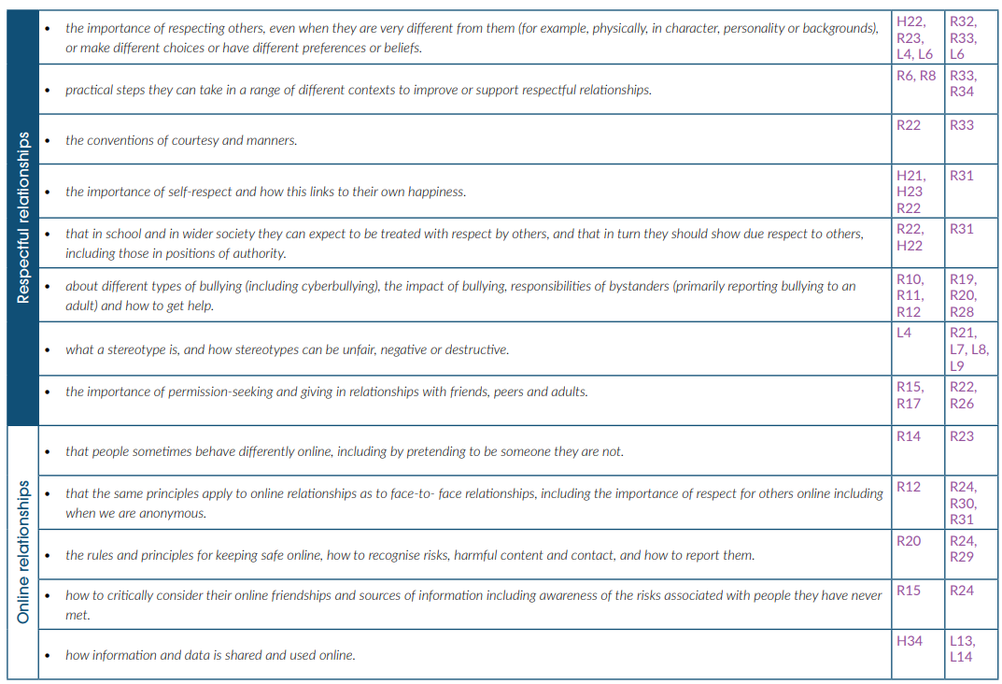
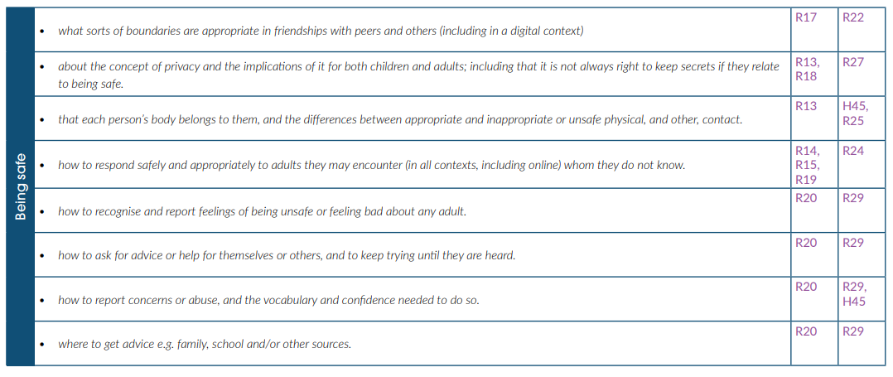

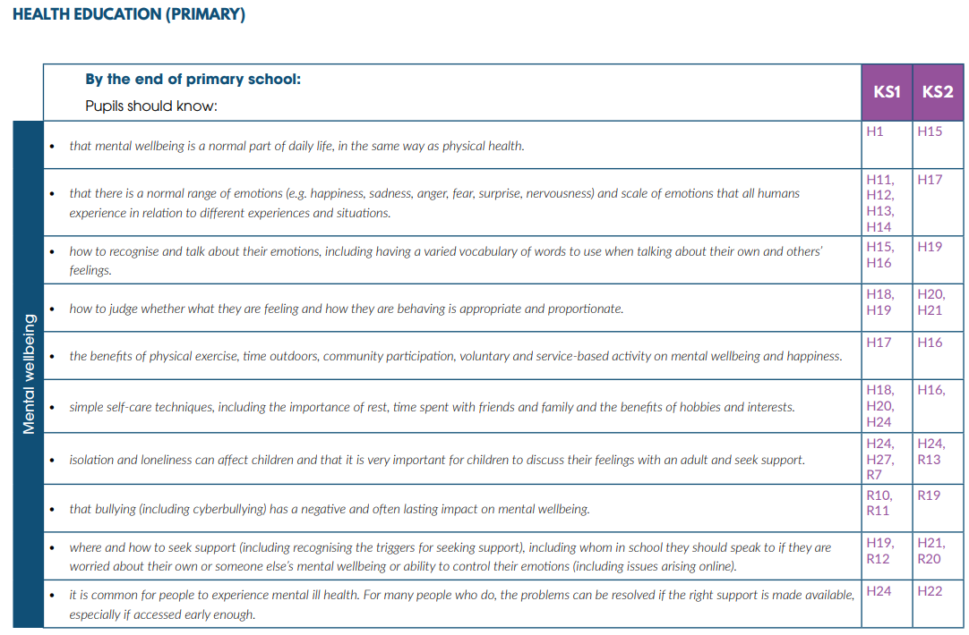
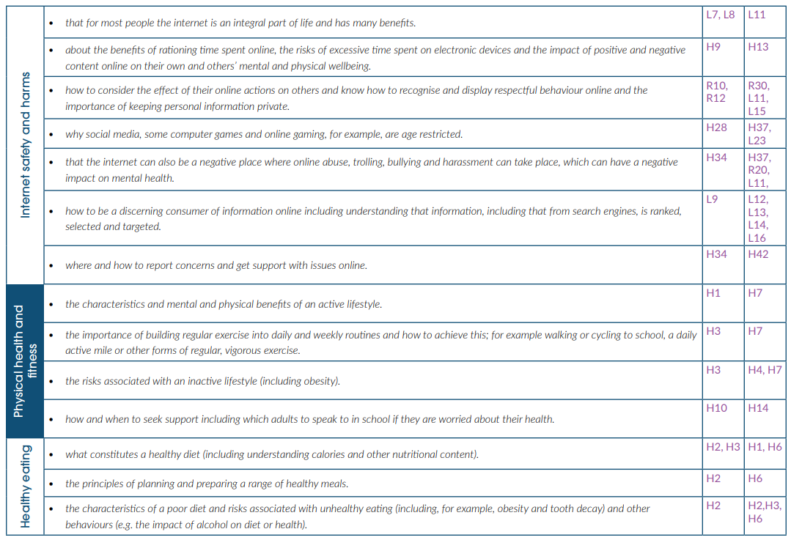
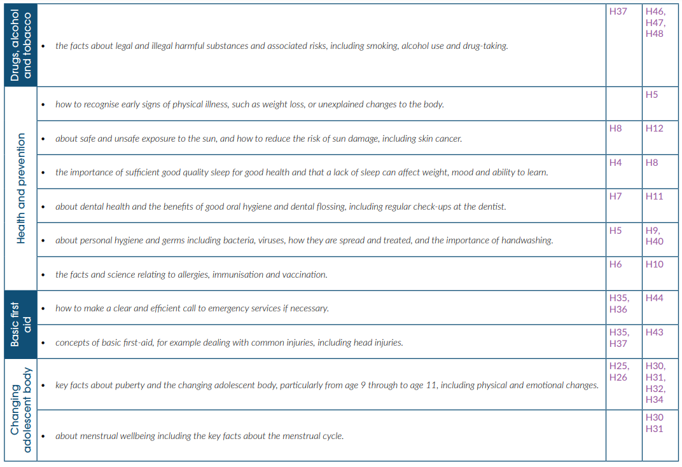
Appendix 3 – PSHE programme of Study



