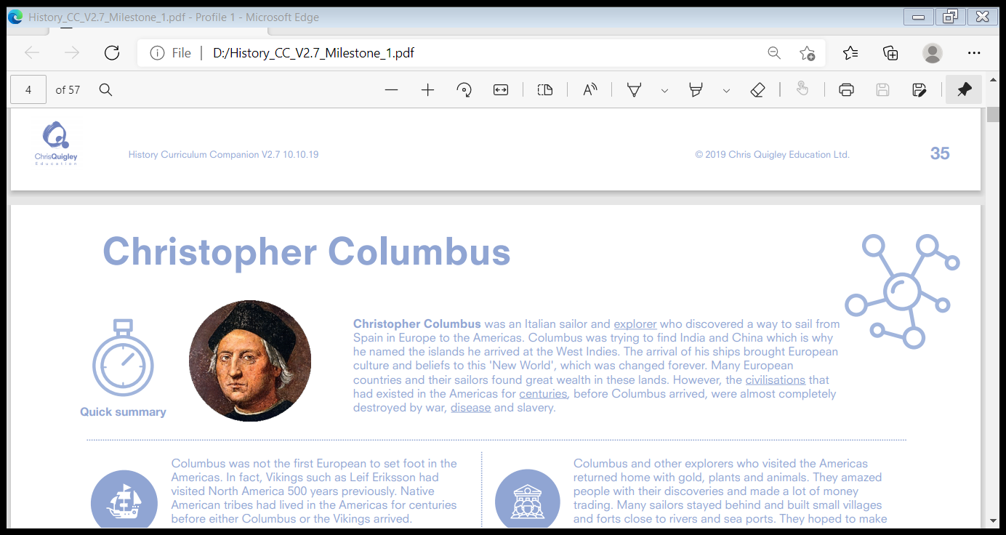
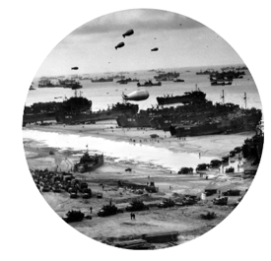
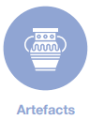

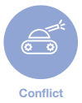

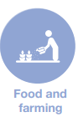



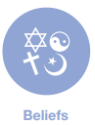

The Second World War
The Second World War was the most deadly conflict the world has ever seen.
It brought into opposition the countries of the Allies (France, Great Britain, the United States and the Soviet Union) and the Axis powers (Germany, Italy and Japan). By the end of the conflict, approximately 50 million people had been killed, and the political and social organisation of the world was changed forever. The end of the war saw Communism growing in the east and a significant shift in power towards the United States in the west. The Second World War is one of the most significant events in history, and its influences are still felt in daily life today.


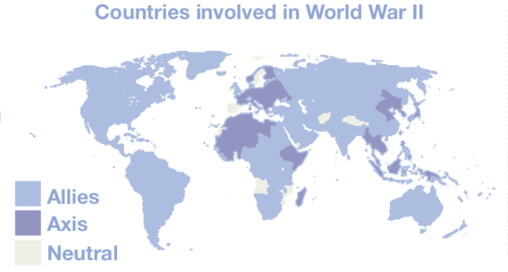

In the decades after the First World War, Europe was still under the threat of another great conflict. Hitler, the leader of the Nazi party in Germany, had come to power promising to rebuild the German army and was soon invading parts of Europe. Britain and France agreed to help Poland if it was invaded, but that didn't stop Hitler. His army moved into Poland, and the Second World War had begun. The conflict involved some of the most famous battles in history, including the Battle of Britain between the British and German air forces. V1 and V2 bombs were created – they were known as ‘revenge weapons’ used by Germany to terrorise British civilians and undermine morale. Pearl Harbour was attacked by the Japanese and brought the United States into the war in 1941. The Second World War also witnessed the use of a powerful new weapon, the atomic bomb, which the USA used on two cities in Japan.
Anne Frank was a German girl and Jewish victim of the holocaust, who is significantly famous for being the only person who kept a diary of her experiences throughout the holocaust war.

In Britain, daily life changed completely as a result of the war. Evacuations took place from London and the Severn Valley. Rationing began in 1940 and didn't end until 1954. Major towns and cities had to be rebuilt after the German bombing raids. The post- war years saw the introduction of a free National Health Service (the NHS).

Influences: effects on what people say or do
Decades: periods of ten years
Evacuated: removed from a dangerous place
Holocaust: the deliberate mass murder of Jews and political prisoners by the Nazis
Legacies: things left behind from the past
Declaration: official announcement dispute: argument or disagreement
Rationing: limiting the amount of food, water or fuel
Significant: important

1939: Germany invaded Poland
1939: Britain and France declared war on Germany
1940: British forces evacuated from Dunkirk
1941: Hitler invaded Russia
1941: The USA entered the war
1942: Mass killings began at Auschwitz

1943: German army defeated at Stalingrad, Russia
1944: D-Day: allied invasion of France
1945: Hitler committed suicide, Germany surrendered
1945: Japan surrendered after the USA dropped two atomic bombs

