
Early Islamic Civilisation: Trade, Baghdad and Travel and Exploration
After the death of the Prophet Muhammed, in 632, the Middle East underwent a period of significant change. Over the next 200 years, Islamic civilisation spread as far as Spain in the west and China in the east. The Golden Age of Islam also saw Muslim artists developing lots of different techniques to decorate textiles, jewellery, glassware and metalwork.
One of the most influential cities in early Islamic civilisation was Baghdad, in modern day Iraq. During the Golden Age of Islam, between 900 and 1200, Baghdad was the largest city in the world, with a population of over 1 million people. It was at the centre of the world’s great trading routes and became a very wealthy city.
Under the rule of the Caliphs, Islamic civilisations grew rapidly, through conflict, conquest and missionary activity. Trade also played a significant role in the spread of Islamic culture and beliefs. Large Muslim populations grew in West Africa, India, China and Spain as people traded goods like salt, spices, gold and textiles.

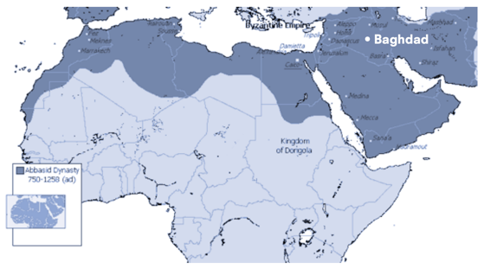

















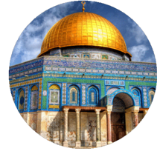
Abbasid Caliphate: a major dynasty that ruled over the Islamic Empire
Caliph: the leader of the Abbasids
arabesques: designs made up of flowing lines
influential: makes people take notice
missionary: people sent to a foreign country to teach about their religion
population: all the people living in a place
era: a long and distinct period of history
irrigation: supplying land with water
Silk roads: an ancient network of trade routes
As well as recording stories and tales from across the globe, Muslim writers also created their stories, perhaps the most famous of that time being One Thousand and One Nights. Sometimes known as The Arabian Nights, it is a collection of short stories including Aladdin, Sinbad and Ali-Baba.

In 762, 12 years after the Abbasid Caliphate gained control, the capital was moved to Baghdad. This move marked the beginning of the free trade of goods, ideas and beliefs across three continents.
The Golden Age of Islam is especially well-known for the use of calligraphy, geometric designs and arabesques to decorate mosques (places of worship for Muslims), buildings and public spaces.

The Silk Roads played a significant part in the development of many civilisations. They brought people together to trade and share ideas, using a vast network of roads that could be travelled along in safety.
Early Islamic civilisation relied heavily, as many great cultures did, on trade and agriculture. Growing various crops, including dates, sugar, cotton and oranges, was essential to feed the rapidly growing populations and to create surplus food to trade. New farming technology, like crop rotation and irrigation, helped to increase yields. Baghdad was the centre of extensive trade routes, including the Silk Roads, that stretched across the world. Goods and produce from as far east as China and as far west as Ireland were brought, sold and exchanged in the market place of Baghdad.

