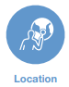
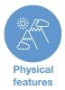

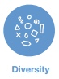
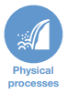
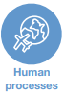
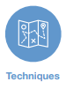
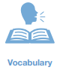
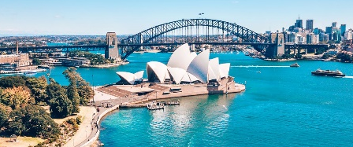
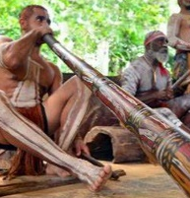
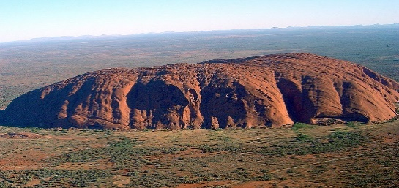
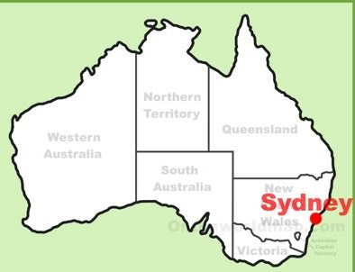
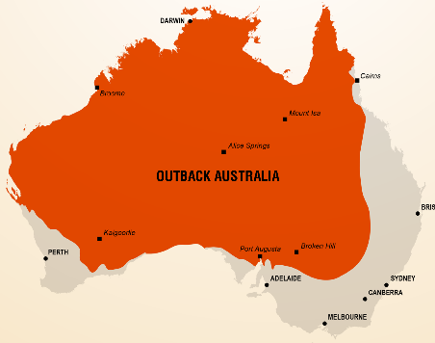
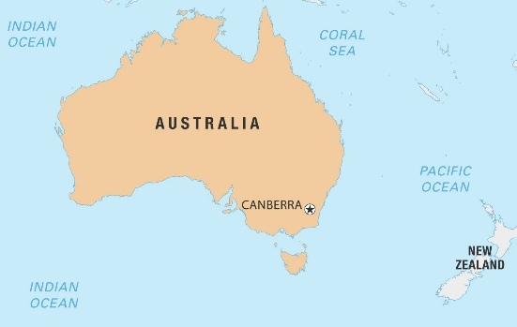
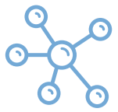
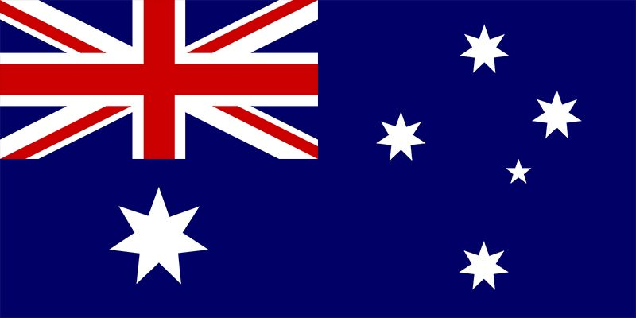
Australia
- Australia is the smallest continent, but the largest island in the world.
- It is part of the Commonwealth and sees Queen Elizabeth II as its queen.
- It has a democratic government and a population of 25 million who mostly live in urban areas.
- The capital of Australia is Canberra, but Sydney is the largest and most famous city.
- The main language is English.
- The indigenous people of Australia are called Aborigines.

Commonwealth – the UK and a group of countries that were ruled by the UK
Democratic – people choose their leaders by voting
Urban – to do with a town or city
Surrounded – all around somewhere
Harbour - part of the sea that has been surrounded by walls
Temperate – not very hot or cold
Settlement – a place where people have come to live
Indigenous – originally from a place
Descendants – people from later generations
Migrants – people who have moved to a different country
Sacred - holy

- Australia is divided into 6 states.
- The cities are all located near the coast.
- Sydney Harbour Bridge and the Sydney Opera House are famous tourist attractions.
- Some Aboriginal people live in villages around Uluru.
The didgeridoo is one of the world’s oldest musical instruments.
Most Aboriginal people live in the desert areas of the outback.
Sydney is built around Sydney harbour on the east coast.
Australia is surrounded by the Indian Ocean and the Pacific Ocean.
The outback is the vast, dry, and remote parts of Australia. Ayres Rock (Uluru) is a huge, sacred rock formation.

