
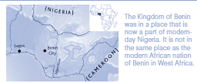



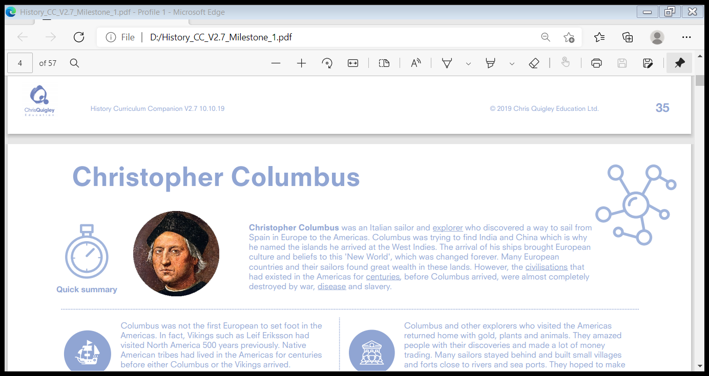










Benin:
The Kingdom of Benin traded and exchanged a range of goods with other African kingdoms and Mediterranean traders. The primary produce of Benin was the yam. Other crops grown for trade included palm oil, beans, melons and okra. The arrival of European traders created a demand for spices like peppercorns, ivory from elephants' tusks and slaves who had been captured by the kingdom's armies. Imports included metals which were used as a form of currency or to make artwork, jewellery and tools. The cowrie shell became highly valued by the Edo and acted as a type of money.
The Edo people worked closely together to build a community of farmers and craftspeople who could trade successfully. They wanted to make things of value, and so they established specialist guilds where people could learn a craft to a very high level of skill. Craftworkers used lots of different materials including iron, bronze, wood and ivory to make pots, tools, weapons and artworks. The Edo people believed brass had the power to keep evil away and so it became one of the most valued materials, used to create beautiful sculptures, plaques and masks. They are some of the finest artworks ever to be created in Africa and tell the rich history of the Edo people.
The Kingdom of Benin was home to the Edo people who, in around 900 CE, began clearing parts of the rainforests of West Africa to build their homes. The Obas led the Edo people to great wealth and power before their kingdom eventually fell under the colonial rule of the British Empire in the late 1800s. The first dynasty of the Edo people, ruled by the Osigos, built the foundations for a great civilisation that became a significant central hub for trade between Southern West Africa and European countries like Portugal. By making their settlements safe and secure the people of the kingdom were able to create the conditions for successful trade. Skilful craftworkers made desirable goods to be sold in marketplaces. With guilds for brass, textiles, ivory, leather and pottery, the empire became very prosperous.
- colonial: relating to a country controlled by a more powerful country
- empire: a number of nations controlled by one country
- trade: to buy and sell goods
- guilds: groups of people who do the same job
- archaeologists: people who study the past by examining remains and objects
- exchanged: swapped
- currency: money

